Info type: Confidential

Company: NTT Data Payment Services India

Info. owner: Product Management Group

**NEFT RTGS | ICICI**



**Document Information**

| **Document Attributes** | **Information** |
| --- | --- |
| ID | NEFT RTGS_ICICI |
| Owner | Product Management Group (PMG) |
| Author | Aviral Tripathi |
| CR No | BRD_20231020_ICICI NEFT RTGS_v1.1 |

**Revision Chart**

This chart contains a history of this document’s revisions.

| **Version** | **Primary Author** | **Description of Version** | **Date Completed** | **Reviewed By** |
| --- | --- | --- | --- | --- |
| 1.0 | Aviral Tripathi | NEFT RTGS via ICICI Nodal | 20/10/2023 | Dharam B. / Nital K. |
| 1.1 | Aviral Tripathi | 1. ‘Reject’ scenario clarified 2. Account TPV debriefed 3. Merchant Webhook Provision 4. Validation – ‘Customer ID’ added 5. Static VAN TPV point added | 03/11/2023 |  |
| 1.2 | Aviral Tripathi | 1. Round-Off Transaction Amount 2. Status change for Transactions & Refunds specified 3. Payout considerations for auto-reversal transactions & scheduled payouts 4. Challan Expiry can be selected in ‘days’ | 11/04/2024 | Dharam B. |

Contents

I. Introduction 3

1.1 Product 3

1.2 Project Scope 3

1.3 Related Documents 4

II. Current System 4

III. Proposed Solution 5

Process Flow : ‘Dynamic’ 5

Process Flow : ‘Static’ 8

TPV Validation 8

TPV API 9

Virtual Account Number Generation 9

Reconciliation 10

Refund 11

Callback API 11

Payout 11

Impact on Merchant Console 13

Impact on Admin Console 14

Impact on Payment Page 16

Impact on Payment Page (Mobile) 16

Impact on AIPay 16

# Introduction

In this document the processes to incorporate payment collections via payment mode as challan i.e. ‘NEFT RTGS’ via ICICI Bank as acquiring bank have been defined.

# Product

**E-Com**

# Project Scope

The scope of this project pertains to the utilization of ICICI bank’s APIs for processing and maintenance of Challan based transactions and replacing the old module ‘IndusInd Bank’ with same.

The scope consists of the below stated payment collection flows –

1. Payment Collection
2. Payment Collection with TPV at NDPS’ end
3. Payment Collection with TPV at Merchant’s end using Challan TPV API

In addition to the above flows, various changes will apply to –

1. Titan –
2. Reports
3. Merchant Onboarding process
4. OTS –
5. API connectivity with Bank
6. API connectivity to Merchant
7. Payment Mode –
8. Dynamic VAN on PG/AIPay
9. Static VAN creation

# Related Documents

The below are the related documents -

|  |  |
| --- | --- |
| **Document Name** | **Attachment** |
| 1. Refund Format (Upload + Download) |  |
| 1. Reconciliation MIS |  |
| 1. API Document |  |
| 1. API Specs & Validations |  |
| 1. Sample File (Upload + Download) – Static VAN Menu 2. Upload 3. Specifications 4. Download |  |

# Current System

This is a new integration for challan-based payment collection. Currently IndusInd bank is being utilized for the challan pay-in facility, which shall be decommissioned, and instead ICICI will be used for same using the existing Nodal account.

# Proposed Solution

## Process Flow : ‘Dynamic’

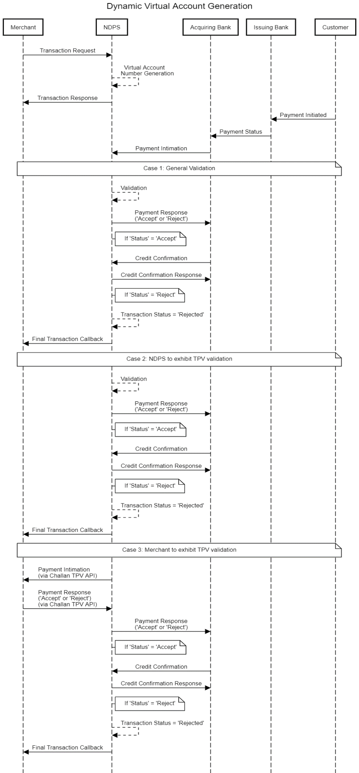

1. Merchant initiates the transaction request to NDPS
2. Unique challan number is generated at NDPS
3. Challan number is sent to the merchant in transaction response
4. End customer utilizes the payment link and Virtual Account Number is displayed

(End customer will later utilize the Virtual Account to make payment via bank)

On the day of payment done by end customer,

1. Bank posts the Payment Intimation on NDPS’ Success URL
2. NDPS validates the transaction details

Case 1 – General Validation

1. NDPS shall validate the transaction details – ‘amount’, ‘Challan expiry’ & ‘Virtual ac no.’
2. On successful validation, NDPS posts the Payment Response as ‘Accept’ via Credit Confirmation API
3. If the original intimation was ‘Accept’, banks posts Credit Confirmation
4. NDPS triggers the Credit Confirmation response to bank

If validation is unsuccessful, NDPS posts the Payment Response as ‘Reject’ via Credit Confirmation API. (For this there will be no response from bank)

Case 2 – TPV at NDPS’ end

1. NDPS shall validate the transaction details along with the payer account number received in Merchant request
2. On successful validation, NDPS posts the Payment Response as ‘Accept’ via Credit Confirmation API
3. If the original intimation was ‘Accept’, banks posts Credit Confirmation
4. NDPS triggers the Credit Confirmation response to bank

Case 3 – TPV at Merchant’s end

1. Bank posts the Payment Intimation on NDPS’ Success URL
2. The intimation is forwarded to the merchant via Challan TPV API
3. Merchant responds to the Challan TPV API
4. Merchant’s response is forwarded to bank via Credit Confirmation API

**Point to note** *- In case NDPS sends ‘Reject’ as response to bank, Credit Confirmation API will not be called by bank.

Also, the transaction will be considered complete with transaction status as ‘Rejected’.

## Process Flow : ‘Static’

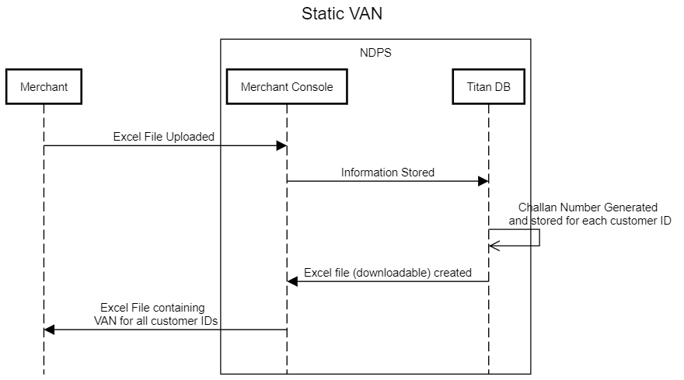

1. Merchant logs in to the Merchant Console
2. Merchant uploads the information in excel file
3. Virtual Account Numbers are uniquely assigned to each entry in the excel file and stored in DB
4. Downloadable excel file with VAN updated for all customer IDs is available on console
5. Merchant downloads the excel file

## TPV Validation

1. If TPV is not enabled for the said Merchant, below validation shall be in effect, which are –
2. ‘amount’ received in the bank callback must be equal to the transaction amount, i.e., the original amount in the merchant transaction request.
3. ‘Challan Expiry’ must be validated
4. ‘Virtual Account Number’ must be validated
5. Validation will be done by NDPS for MIDs for which ‘TPV’ is enabled –

Account details are validated by NDPS using the transaction details sent by acquiring bank; here ICICI bank.

1. If details are validated, Status = ‘Accept’ in ‘Credit Confirmation’ API
2. If details are not validated, Status = ‘Reject’ in ‘Credit Confirmation’ API

For Validations, please refer the ‘API Spec & Validation’ excel in the Related Documents section.

1. Validation will be done by Merchant for MIDs for which ‘TPV’ is enabled. Merchant will utilize ‘**TPV API**’ if they require to validate customer info and thereby response NDPS to Accept / Reject the payment. (For API details refer TPV API in ‘Related Documents’)

If the above is not the case, the transaction will be rejected and callback for the said transaction will not be posted.

**Note** * - ‘TPV’ shall be applicable for VAN generated using Bulk upload file i.e., Static VAN. For same system must store the generated VAN along with the end customer’s bank account Number

## TPV API

PFA the specifications and validations for the TPV API in the attached excel file in the Related Documents section.

Account details are validated by Merchant using the transaction details sent by NDPS over TPV API Callback, there will be below scenarios -

1. If in TPV API Response, Status = ‘Accept’ in ‘Credit Confirmation’ API, same is echoed in Credit Confirmation API to bank
2. If in TPV API Response, Status = ‘Reject’ in ‘Credit Confirmation’ API, same is echoed in Credit Confirmation API to bank

## Virtual Account Number Generation

Merchants will either be generating dynamic or static VPA, below are the specifics -

1. **Dynamic VAN**

On clicking the ‘Pay Now’ button on payment page, the account number will be generated based on P&C taking in account the below parameters (i.e., Account Number = (i) + (ii) + (iii) ) –

1. ICICI Client Code (Prefix) - **ATOMCL**
2. Atom MID - **548632**
3. Configurable Input – Uniquely populated digits to form a total of minimum 12 digit a/c no.

**In case of static -**

Eg - Suppose (iii) = 48457585, then the last 6 digits are considered, thereby the account number = **NDPS54863200457585**

A uniquely assigned value will be assigned or suffixed to the respective value for component (iii).

**Note**\* -

For Dynamic VPA, ‘Accept’ response will only be sent for the first successful transaction. Any payment callback from bank thereafter will be sent as ‘Reject’ status and payment initiation entry will be available in the report.

1. **Static VAN**

On clicking the ‘Pay Now’ button on payment page, the account number will be generated based on P&C taking in account the below parameters (i.e., Account Number = (i) + (ii) + (iii) ) –

1. ICICI Client Code (Prefix) - **ATOMCL**
2. Atom MID - **548632**
3. Configurable Input –

If Merchant passes a unique identifier in parameter ‘custId’ in the transaction request, the last 6 digits of this identifier will be considered as the remaining characters of the account number –

E.g. - Suppose (iii) = 48457585, then the last 6 digits are considered, thereby the account number = **NDPS54863200457585**

A uniquely assigned value will be assigned or suffixed to the respective value for component (iii).

## Reconciliation

The attached file format (E-Collection MIS) will be received from the bank via e-mail.

(Frequency – EOD / BOD/ Hourly **- TBD**) and uploaded in Admin Console in the below menu à

Reconciliation à NB PG Recon; wherein new Bank: ‘ICICI NEFT’ will be available to select for ‘CARD BASED’ product for ‘Online’ channel. On uploading, Recon Status will convert to ‘RNS’.

Note*- Duplicate entries in recon file must not be accepted and must occur in mismatch file - ‘AtomTxnID’ & ‘BankRRN’

File Format : Refer Related Documents

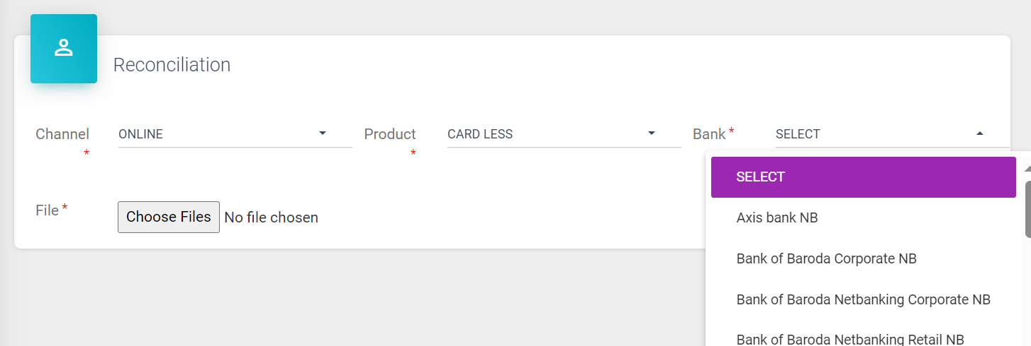Upload files to be available in Upload Data -> ’File Status’

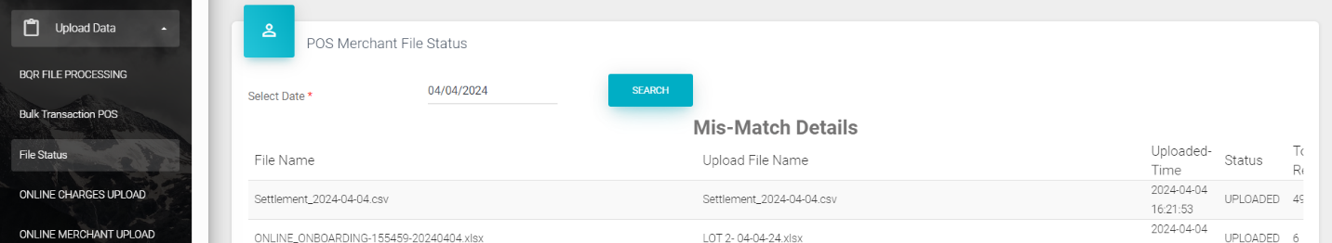

## Refund

To initiate refund for any given transaction the attached file format will be utilized (Refer Related Documents)

This file must be placed in a SFTP folder designated for processing refunds for product NEFT-RTGS, and the refund confirmation file will fall in the same folder by bank.

Once reversal file is uploaded to TITAN, refund date & Refund RRN must be captured in TITAN.

Once the file is received in the designated folder by bank, the status of successful refunds must be updated to ‘REFUND PROCESSED AT BANK’ in the refund file downloaded from menu: Refund -> Online Channel Refund -> ‘View’, for all ‘Atom Txn ID’.

‘REFUND FAILED AT BANK’ if status is ‘FAILED’ in Refund Recon file

## Callback

1. Callback will be triggered for each instance of change in transaction status via Callback API
2. Final Callback will be triggered to Merchant on posting of either ‘Accept’ or‘Reject’ to Bank for the said transaction.

**Note**\* - Callback must be triggered immediately on transaction success.

**Transaction Status**

1. Transaction Status shall be ‘Pending’ on transaction request from Merchant
2. Input in ‘Txn Status’ must change from 'PENDING' to 'OK' once the transaction is 'Success' at Bank's end
3. Transaction Date will be overridden with actual transaction date

## Payout

Existing ICICI file will incorporate the Challan Payout transactions. The merchant will be bifurcated as –

1. Net Settlement
2. Gross Settlement

For same, product ‘National Electronic Funds Transfer’ must be enabled in ‘Gross Settlement’ under ‘Channel Information’ sub-menu in merchant onboarding. Refer below screenshot –



Based on the reconciliation MIS for transactions & refund, the Sale & Refund transactions will reflect and be adjusted in the ICICI payout file (as per the current process).

Transaction:

1. All ‘RNS’ will reflect in both payout ‘Regular’ & ‘Charges’, as per the current process.
2. Txn status like ‘AR’ etc. Must also reflect in payout.

Refund:

1. Post Refund Recon file (with UTR) is uploaded in Titan on T-day, same must be adjusted in Payout based on refund reversal file received from bank upload in TITAN.

**Note\*** - Auto Reversal transaction must not be adjusted in merchant payout file and for such transactions the current process will be followed. Such refunds will be closed based on the below upload file.

**File format** - <https://atomtech-my.sharepoint.com/:x:/g/personal/bhavisha_parmar_atomtech_in/EQXaIaEmVaJDjekTfBnSW84BOHvJ6kTF48LkIPGDB1a7Jw?e=9zGgKi>

Post retrieval of Payout Reversal File, status for transactions will convert to ‘RS’, ‘UTR No’ & ‘Settlement Date’, along other parameters will get updated as per the current process.

For refunds, Refund Status will change to ‘REFUND CLOSED’ and relevant parameters will be updated in report.

## Amount

Total Amount must always be a whole number (as per the current process)

E.g. – 415.01 to 415.49 == 415

415.50 to 415.99 == 416

## Billing

Merchant / Bank Billing -

All charges must apply based on the configuration in Titan and must appear in the ‘charges’ payout.

it will be available in the monthly billing report under “Merchant Broker Payout Charges”

## Impact on Merchant Console

1. Reports: The transactions held will be available in the transaction & settlement reports; Refunds will be available in the Refund report.
2. Static VAN Creation (Bulk):

Refer the below snapshot for the provision to retrieve Challan Numbers in Bulk –

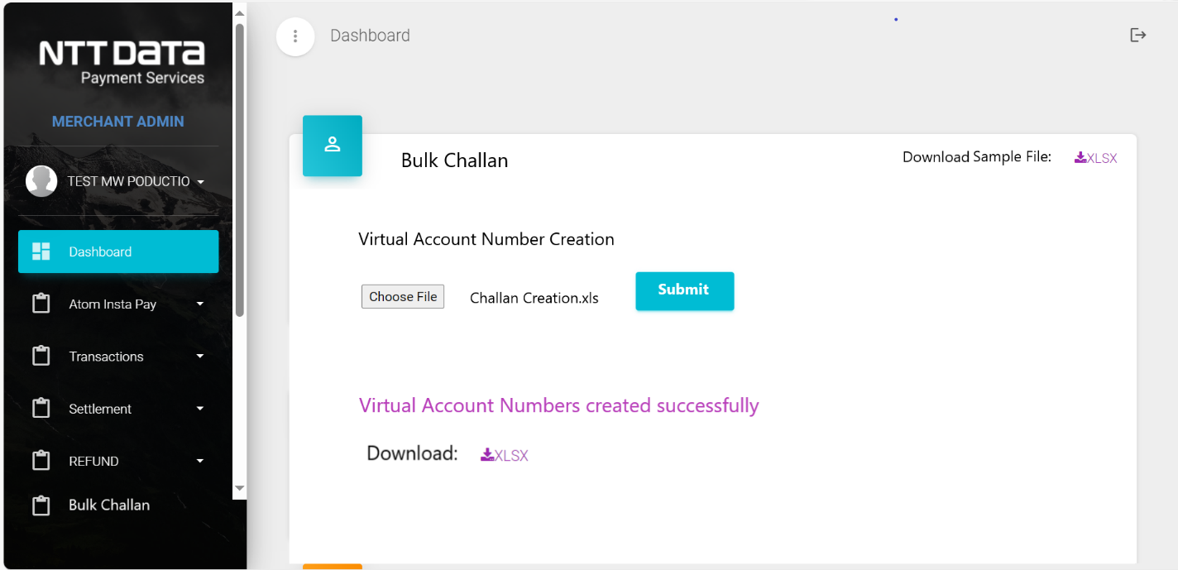

1. User may upload ‘.xls’/ ‘.xlsx’ format
2. The downloadable will be an excel file in ‘.xls’ format and will be available to download as soon as the user uploads file with customer details.
3. If any duplicate ‘Customer ID’ exists in the file being uploaded, Error ‘Duplicate Customer ID not allowed’ must occur on page; such file will not be uploaded
4. Below sample file will be available to download on top-right corner. Below is the sample file –

Sheet 1 : Format

Sheet 2: Specifications



**Note * -** For Static VAN -

1. Multiple transactions can occur against the generated Virtual Account Number. Thereby system must store multiple transaction responses from the bank against the generated VAN in case of ‘Static VAN’.
2. Transaction status, Callback, Recon & Payout implementations will be same as mentioned above, but for every transaction seperately.

## Impact on Admin Console

1. Reconciliation: Yes, as stated in the Reconciliation section
2. Payout and Settlement: Yes, the payout will be generated post-reconciliation
3. Refund: Yes, as stated in the Refund section.
4. Chargeback: No
5. Maker-Checker: Yes, activation of payment mode shall be based on checker approval
6. Surcharge Applicability: Yes, surcharge must be applicable depending on configuration.
7. Reports: The transactions held will be available in the transaction & settlement reports. Refunds will be available in the refund report. The status of transactions/refunds will be updated depending on the status received/fetched from bank.

Reports impacted –

1. Transaction (Admin)
2. Transaction (Merchant)
3. Settlement (Admin)
4. Settlement (Merchant)
5. Refund (Admin)
6. Refund (Merchant)

In the Transaction Reports – field ‘Auth No’ currently consists of ‘VAN’ and same process will be followed. Also, in the Settlement Reports – field ‘Bank Ref No’ currently consists of ‘VAN’ and same process will be followed.

Field - ‘Transaction Date’ will be over-ridden with the

1. Payment option and charges option: No
2. Charges Configuration : Yes, below is a snapshot of the charges menu config along with description, wherein ‘Online’ sub-menu is selected for the charges configuration of the product type ‘NEFT-RTGS’.

Bulk Charges Upload file format: Will be shared at the time of development.

The configurations will be fetched from Master files. (Will be shared later)

1. Merchant Configuration :

Below are the changes applicable in merchant configuration menu -

1. In ‘Channel Information’, ‘Challan Expiry’ currently allows only 2-digit input, must be changed to 5 digits.

Eg. – Challan Expiry = ‘90’ Hours, implies that transaction will be Rejected due to validation failure.

1. In ‘Channel Information’, new option for the selection of ‘Challan Type’ will be available, wherein –

‘Dynamic’ will be the default selection, whereas the user can select ‘Static’ for the provision of the menu for Static VAN on ME console

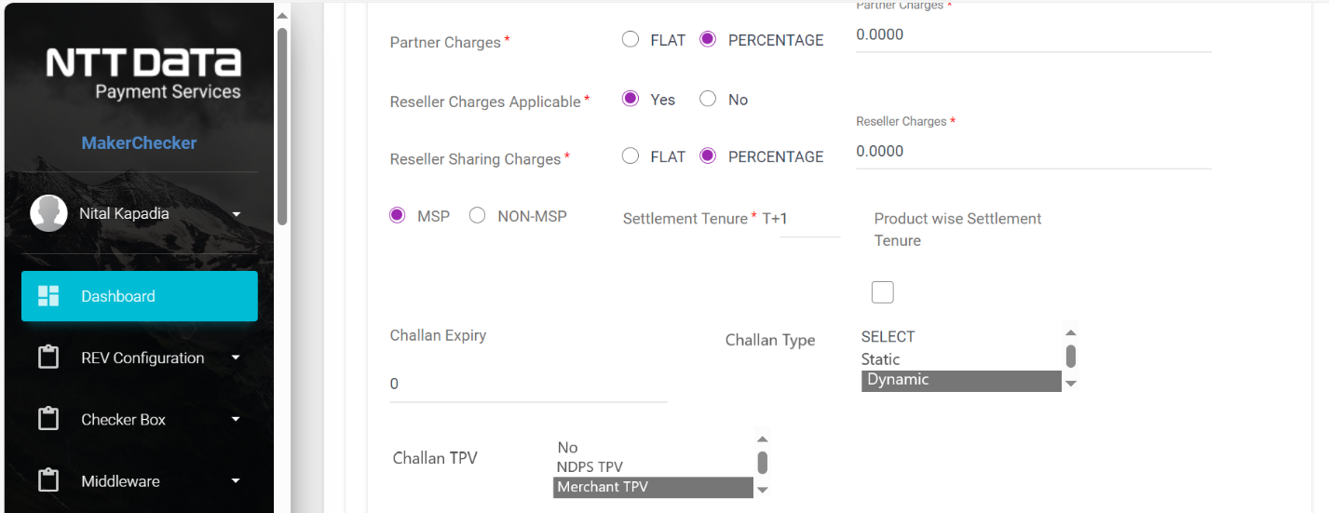

1. In ‘Channel Information’, new option for the selection of ‘Challan TPV’ will be available, wherein –
2. ‘No’ implies ‘General Validations’
3. ‘NDPS TPV’ implies TPV by NDPS i.e., NDPS validates Customer Account basis the account number received in request
4. ‘Merchant TPV’ implies that Merchant will be posting ‘Accept/Reject’ parameter
5. In ‘Channel Information’, new option to configure the ‘Challan Callback URL’ will be available, wherein the callback URL to trigger API call (Payment Intimation) will be configured
6. The above-mentioned menu items – ‘Challan Expiry’, ‘Challan Type’, ‘Challan TPV’ & ‘Challan Callback URL’ will be available to input data only if ‘Product’ – ‘National Electronic Funds Transfer’ is selected

**Note**\* - Callback URL, Challan TPV & Challan Type are Mandatory to be configured if ‘NEFT-RTGS’ product is selected.

Refer TPV Validation section for the implications of selection of ‘Challan Type’ & ‘Challan TPV’ mentioned above.

**Bulk Merchant Info Onboarding** **:**

Format :



Added : Challan Expiry, Challan Type, Challan TPV, Challan Callback URL in columns CY, CZ, DA, DB respectively.

Refer above excel for sample inputs.

**Bulk merchant Download File** : In ‘Channel Info’ sheet -

Format :



Added: Challan Expiry, Challan Type, Challan TPV, Challan Callback URL

**Bulk Charges Config :**

Charges must be configured as per the updated charges configuration as per New Fee Structure.

File Format:



## Impact on Payment Page

Yes, the challan generated on the payment page will be as per this BRD.

## Impact on Payment Page (Mobile)

Yes, the challan generated on the payment page will be as per this BRD.

## Impact on AIPay

Yes, the challan generated on the payment page will be as per this BRD.